PRESS RELEASE
No. 138/SP/TKP-ASEAN2023/8/2023
PUBLIC COMMUNICATIONS TEAM

FOR IMMEDIATE RELEASE

Indonesia Calls for ASEAN Collaboration to Produce Concrete Solutions in AFTA
Jakarta, Kominfo Newsroom – Indonesia calls on ASEAN countries to prioritize the spirit of togetherness and collaboration in formulating concrete solutions to strengthen trade among ASEAN countries.
This was a statement made by Minister of Trade Zulkifli Hasan during the opening of the ASEAN Free Trade Area (AFTA) Council Meeting which was part of the 55th ASEAN Economic Ministers’ Meeting held in Semarang, Central Java, on 19 August 2023.
“This meeting is an important momentum to strengthen intra-ASEAN trade. I hope that we can collaborate by prioritizing the spirit of togetherness and providing a clear direction, as well as formulating real and concrete solutions,” said Zulkifli Hasan
The Minister of Trade stated that Indonesia, as the holder of the ASEAN Chairmanship in 2023, hopes that ASEAN countries can have active roles in promoting various regional and global agendas. ASEAN countries are also expected to develop an adaptive, responsive, and highly competitive region that serves as the epicentrum of global economic growth.
“These efforts must be supported by our collective endeavor to achieve fair, inclusive, and sustainable regional economic growth,” said the minister.
Aside from the delegations of the economic ministers from the 10 ASEAN member states, the Minister of Commerce and Industry of Timor-Leste Filipus Nino Pereira also attended the meeting as an observer.
Pereira said that Timor-Leste has been observing and taking notes of ASEAN’s commitment to addressing immediate challenges and providing recovery initiatives after the COVID-19 pandemic. ASEAN made these efforts to promote cooperation in the digital economy, circular economy, and green economy sectors, as well as to strengthen food security and supply chains in anticipating crisis impacts.
“We are fully committed to the ASEAN Free Trade Agreement, its principles, objectives, and guidelines as an additional pillar of regional economic cooperation and integration to address ongoing and emerging challenges,” said Pereira.
The 55th ASEAN Economic Ministers’ (AEM) Meeting has started from 17 August to 22 August 2023. On the first day, Indonesia chaired the ASEAN Senior Economic Officials Meeting that continued until Friday, 18 August, before moving on to the ministerial-level meeting from Saturday, 19 August, until 22 August. (Indra Arif Ant/TR/Vr/WW).

***
For more information, please contact:
Director General of Public Information and Communications of the Ministry of Communications and Informatics – Usman Kansong (0816785320).
Get more information at http://infopublik.id.
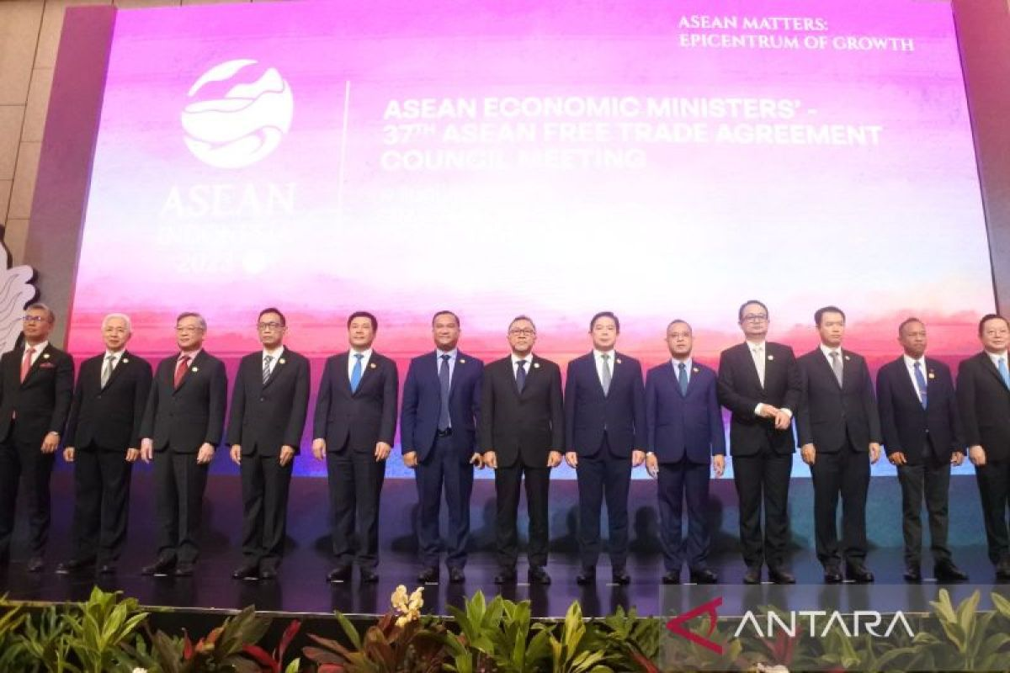
Indonesian Minister of Trade Zulkifli Hasan (center), along with economic ministers from ASEAN member states and the observer country Timor-Leste, take a group photo during the ASEAN Free Trade Area (AFTA) Council Meeting. The meeting is part of the 55th ASEAN Economic Ministers’ Meeting held in Semarang, Central Java, on 19 August 2023. ANTARA/Indra Arief Pribadi.

